# Isabel Llanos Chaparro, Pilar Sanchez-Beltran, Edison Henao Carvajal

Universidad Nacional de Colombia

# Obregón & Valenzuela

Rafael Obregón, Jose María Obregón and Pablo Valenzuela founded the architectural practice Obregón & Valenzuela in 1944.[1] In 1982 this firm abandoned its activity in urban and architectural design to create the building company Obreval SA[2] in partnership with Ospinas Cia SA. From the 1950s until the 1970s, Obregón & Valenzuela conceived around 140 projects, being one of the most prolific firms in Colombia, while leading the dissemination of modern architecture in the country. Their architectural production includes commercial, educational, social, industrial and institutional buildings.[3] A highlight of their work is a series of private houses, banks, and social clubs built in different cities, such as Bogotá,[4] Barranquilla and Cartagena.[5]

Rafael Obregón González (Barcelona, 1919 – Bogotá, 1976) received an honours degree of Bachelor of Architecture from the Catholic University of America (Washington D.C.) in 1944. In the 1950s he lectured in architecture at the Universidad Nacional de Colombia and Universidad de los Andes. He was a member and subsequently president of the Society of Colombian Architects, and an honorary member of the Society of Architects in Chile and Venezuela. It was under his leadership that most of the significant projects of this firm were developed.[6] An exceptional sailor, spear fisherman, boxer and racing car driver, he took advantage of his active social life in securing commissions for Obregón & Valenzuela.

Jose María (Pepe) Obregón Rocha (Bogotá, 1921-1982) also received the degree of Bachelor of Architecture from the Catholic University of America in 1944. He went on to lecture in architectural design at the Universidad Javeriana and Universidad de los Andes. He was a board member of the Society of Colombian Architects, and a member of the executive board of the Panamerican Congress of Architects held in Bogotá in 1968. The quality of the projects led by him was a determining factor in the recognition of this firm. He was also a water-colourist, and staged several individual and collective exhibitions of his works. Unlike his cousin, Rafael Obregón, Pepe Obregón was an introvert and contemplative.

Pablo Valenzuela y Vega (Bogotá, 1920-1954) also held a Bachelor of Architecture from the Catholic University of America. He was a member of the Society of Colombian architects, and the firm’s manager until his early death.

Obregón & Valenzuela pioneered the introduction of international trends, by adapting universal principles to the local context.[7] The remarkable architecture of this firm demonstrates an interest in relating the architectural object to the urban dynamic, through generous openings in the ground floor of tall buildings. In their lower-scale architecture, they achieved a connection between the interior space and the surrounding landscape, by using free-standing plants, crystal walls, and exuberant interior gardens.[8]

## Selected works

1951 Álvaro López house in Bogotá.

1951 Mario Santodomingo house in Barranquilla.

1955-58 Naval College in Cartagena.

1955-56 Country Club in Ibagué, with Gabriel Solano.

1956 Rafael Obregón house in Bogotá.

1957 Eduardo Shaio house in Bogotá.

1959-61 French and Italian bank in Bogotá.

1962-66 Bavaria complex in Bogotá, with the firm Pizano-Pradilla-Caro.

## References and further reading

Arango, J., & Martínez, C. (1951). *Arquitectura en Colombia : arquitectura colonial 1538-1810, arquitectura contemporánea en cinco años 1946-1951*. Bogotá: Proa.

LLanos, I., Henao, E., Fontana, M. P., & Mayorga, M. (2012). Obregón & Valenzuela en Bogotá 1949-1969. In U. N. d. Colombia (Ed.). Bogotá: Universidad Nacional de Colombia.

Martínez, C. (1950). Obregón & Valenzuela. *Proa, 36*(junio), 11.

Mendoza Neira, P. (1965). *Lo mejor del urbanismo y de la arquitectura en Colombia*. Bogotá: Libreria Colombiana Camacho Roldan.

Sánchez-Beltrán, P. (2010). Memoria del proyecto arquitectónico original de la Escuela Naval de Cadetes 'Almirante Padilla'. *La Corredera, 120*(75 años - special issue), 30-35.

## Visual Material:

Revista PROA[9]

Archivo Stoller[10]

Revista DPA[11]

Gaceta del Patrimonio[12]

Exposición OV[13]

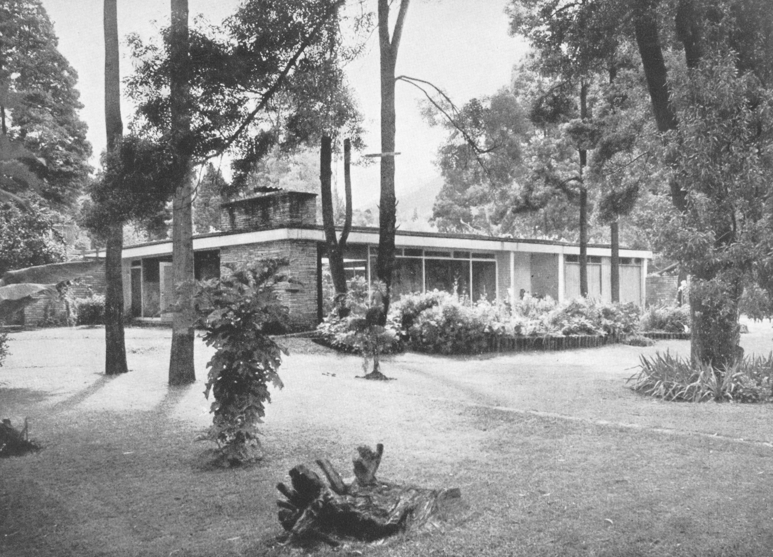

Álvaro López house in Bogotá (1951)

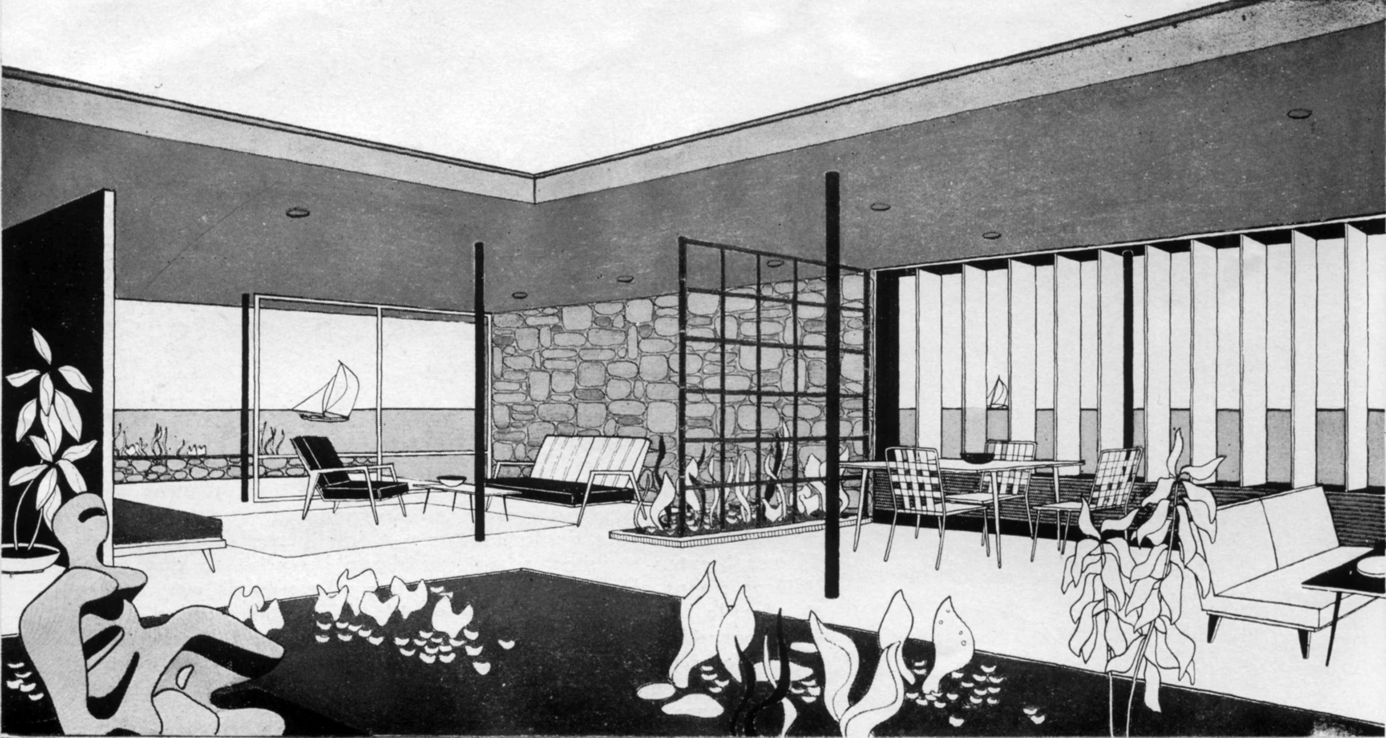

Mario Santodomingo house in Barranquilla (1951)

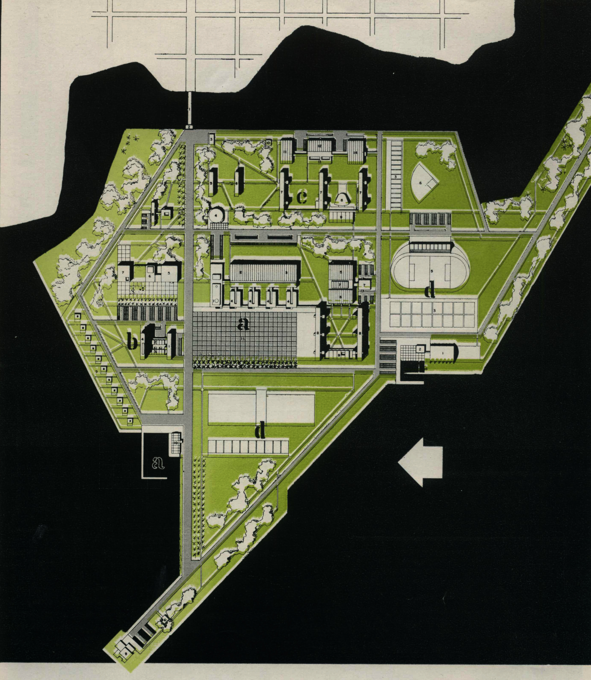

Naval College in Cartagena (1955-58)

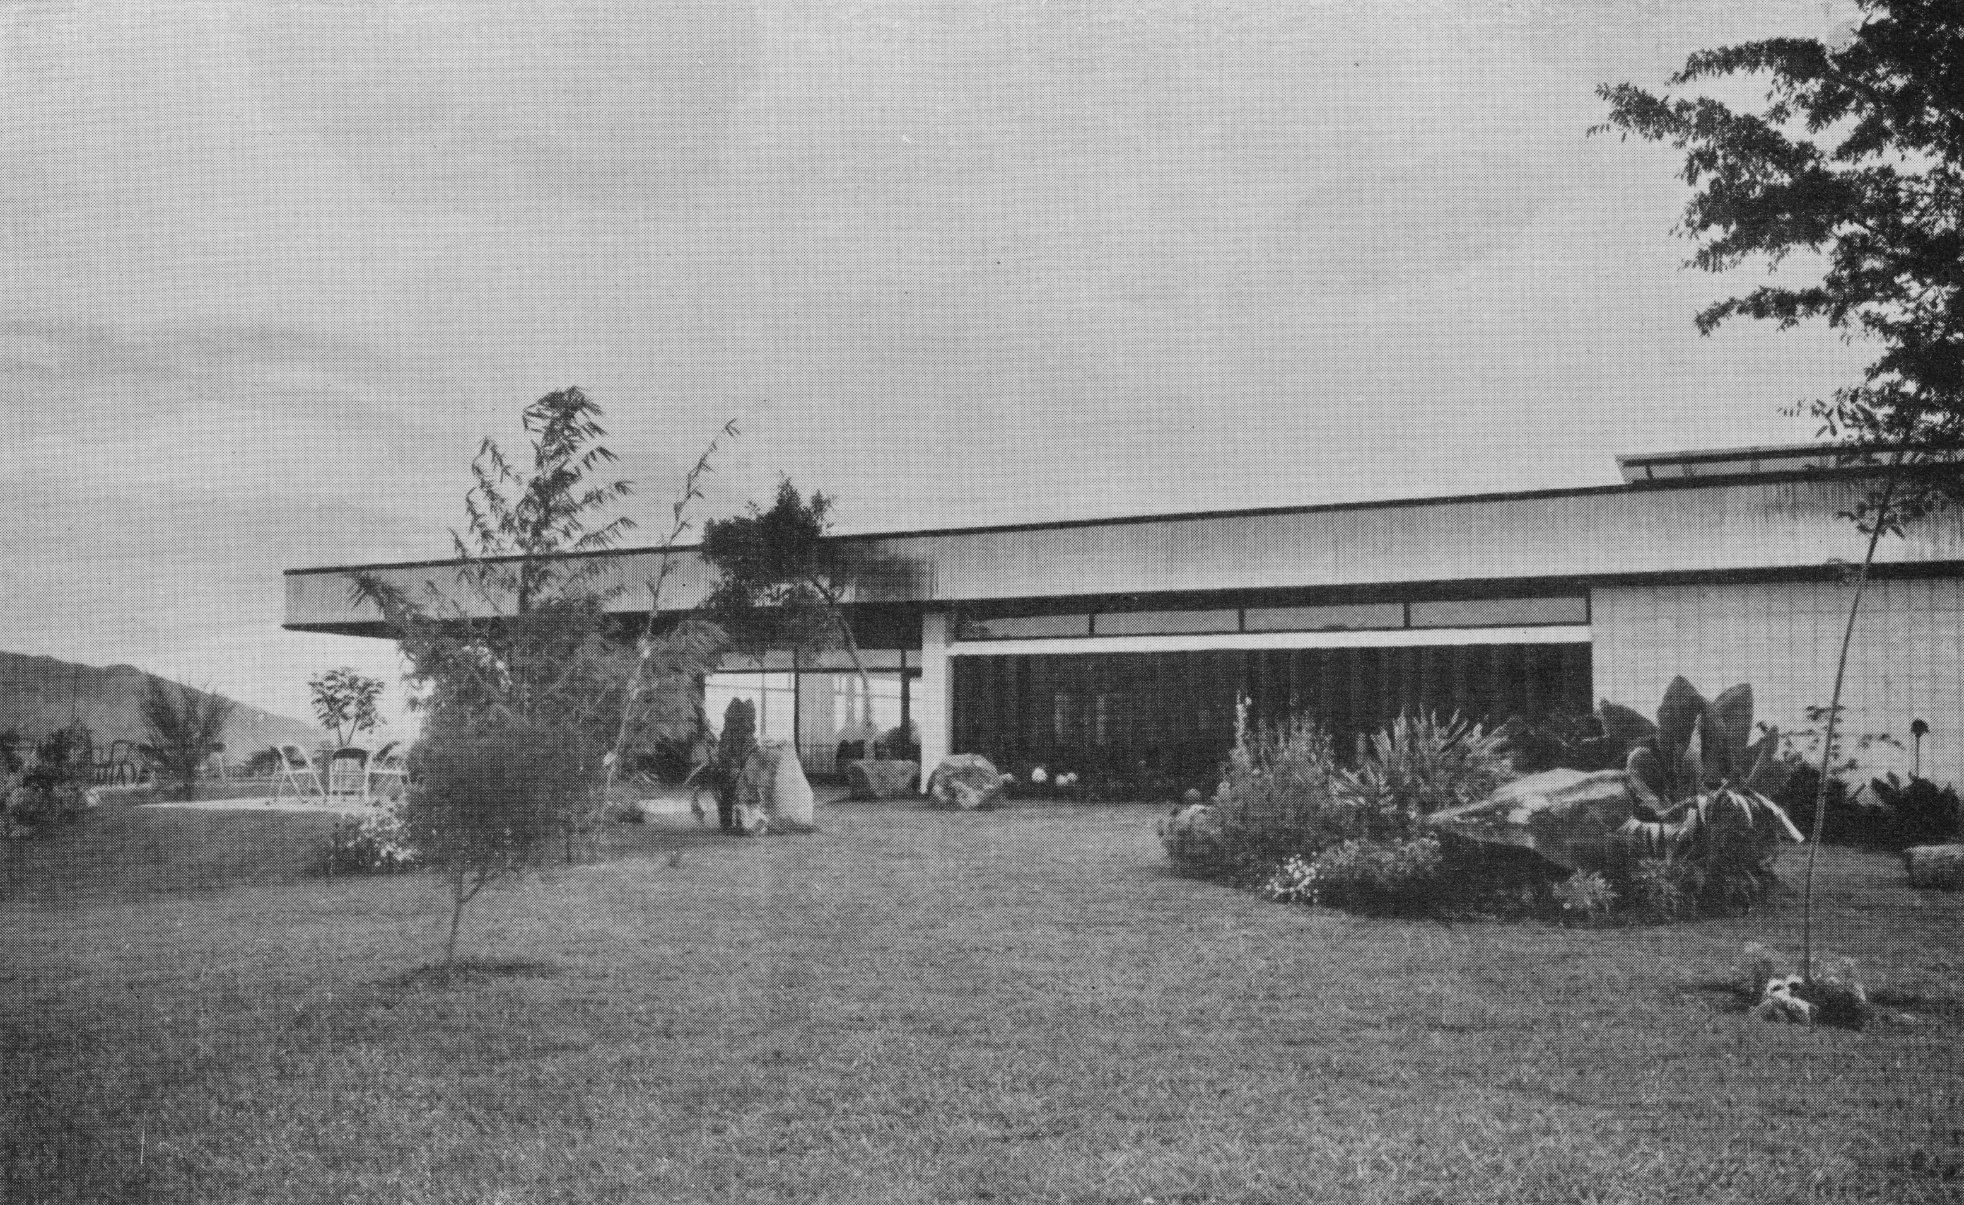

Country Club in Ibagué, with Gabriel Solano (1955-56)

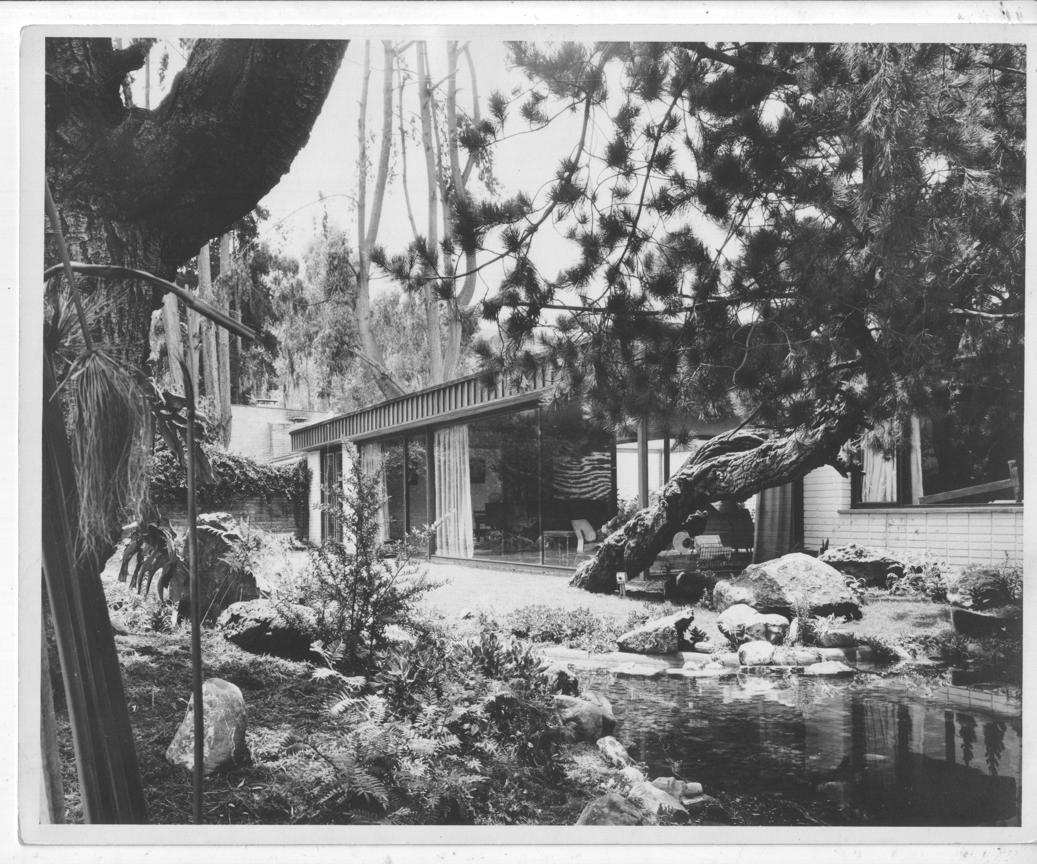

Rafael Obregón house in Bogotá (1956)

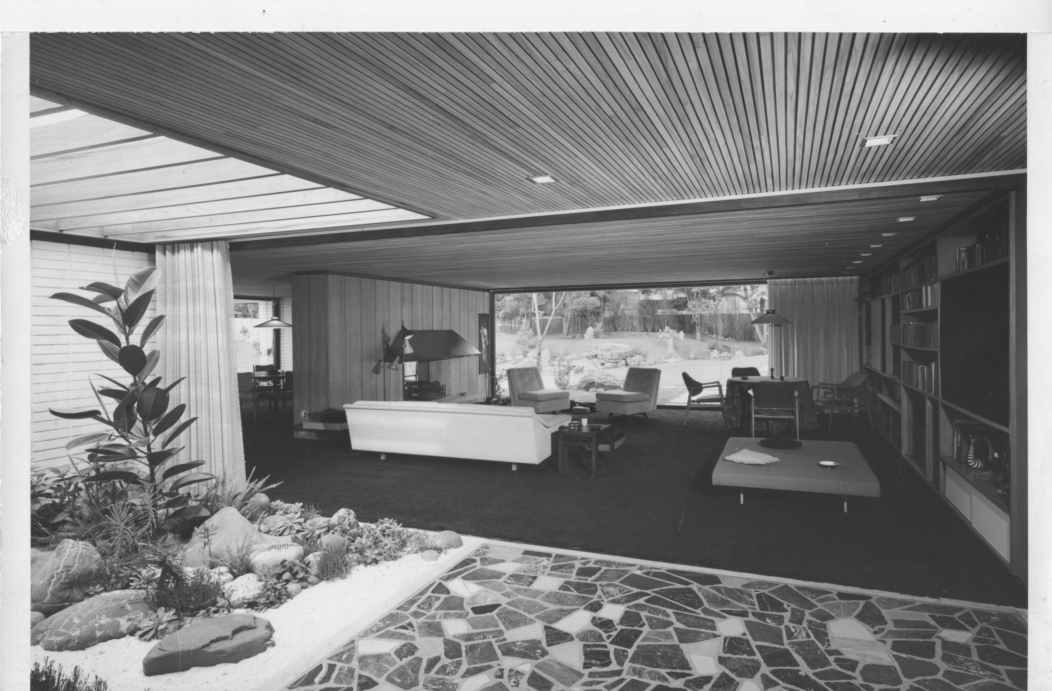

Eduardo Shaio house in Bogotá (1957)

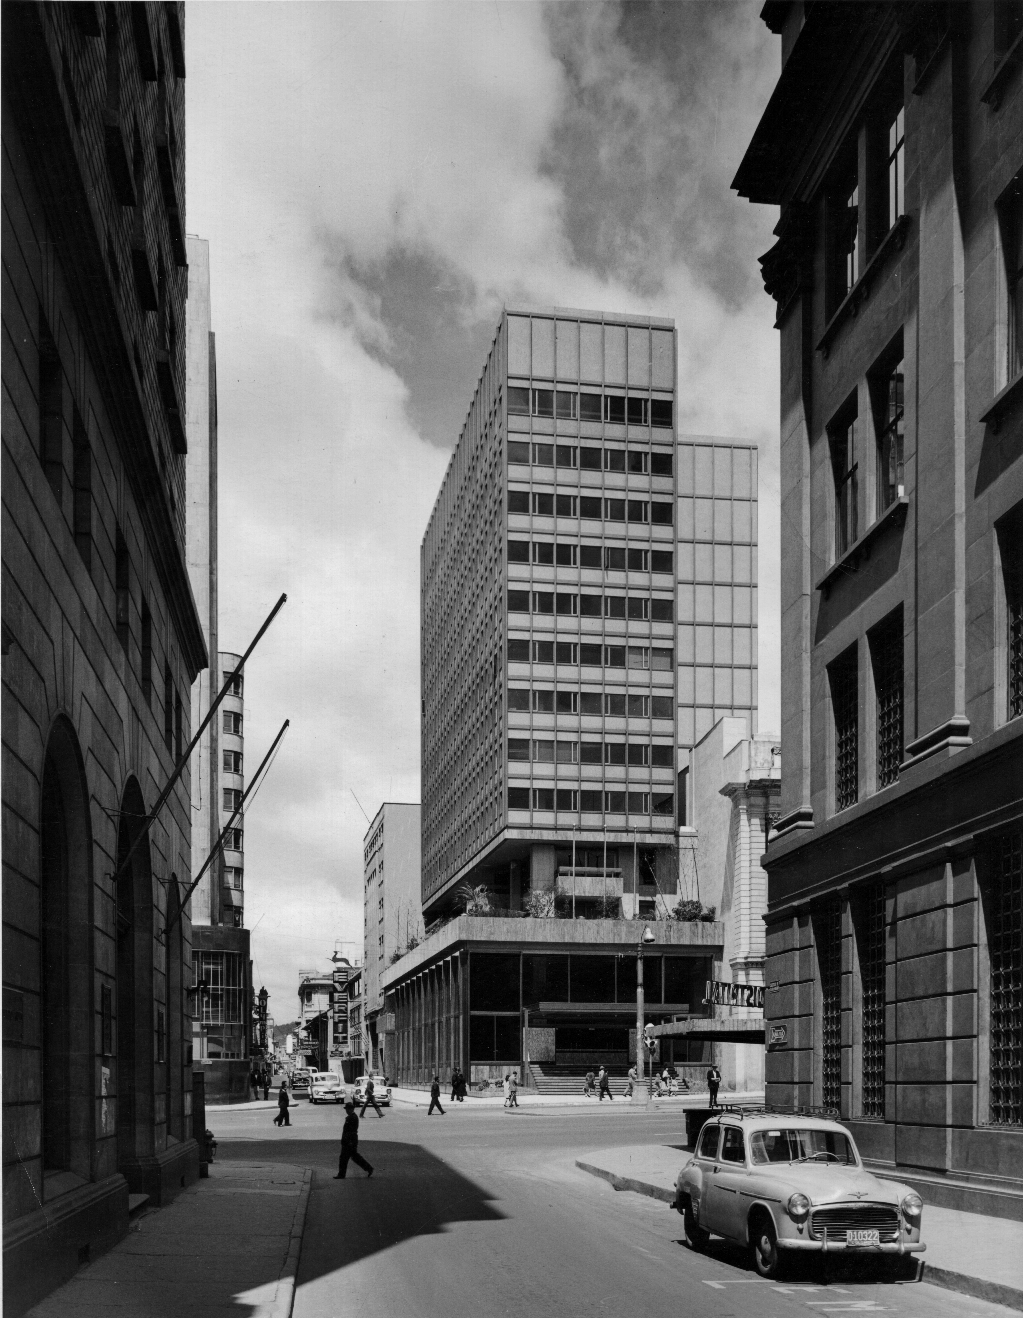

French and Italian bank in Bogotá (1959-61)

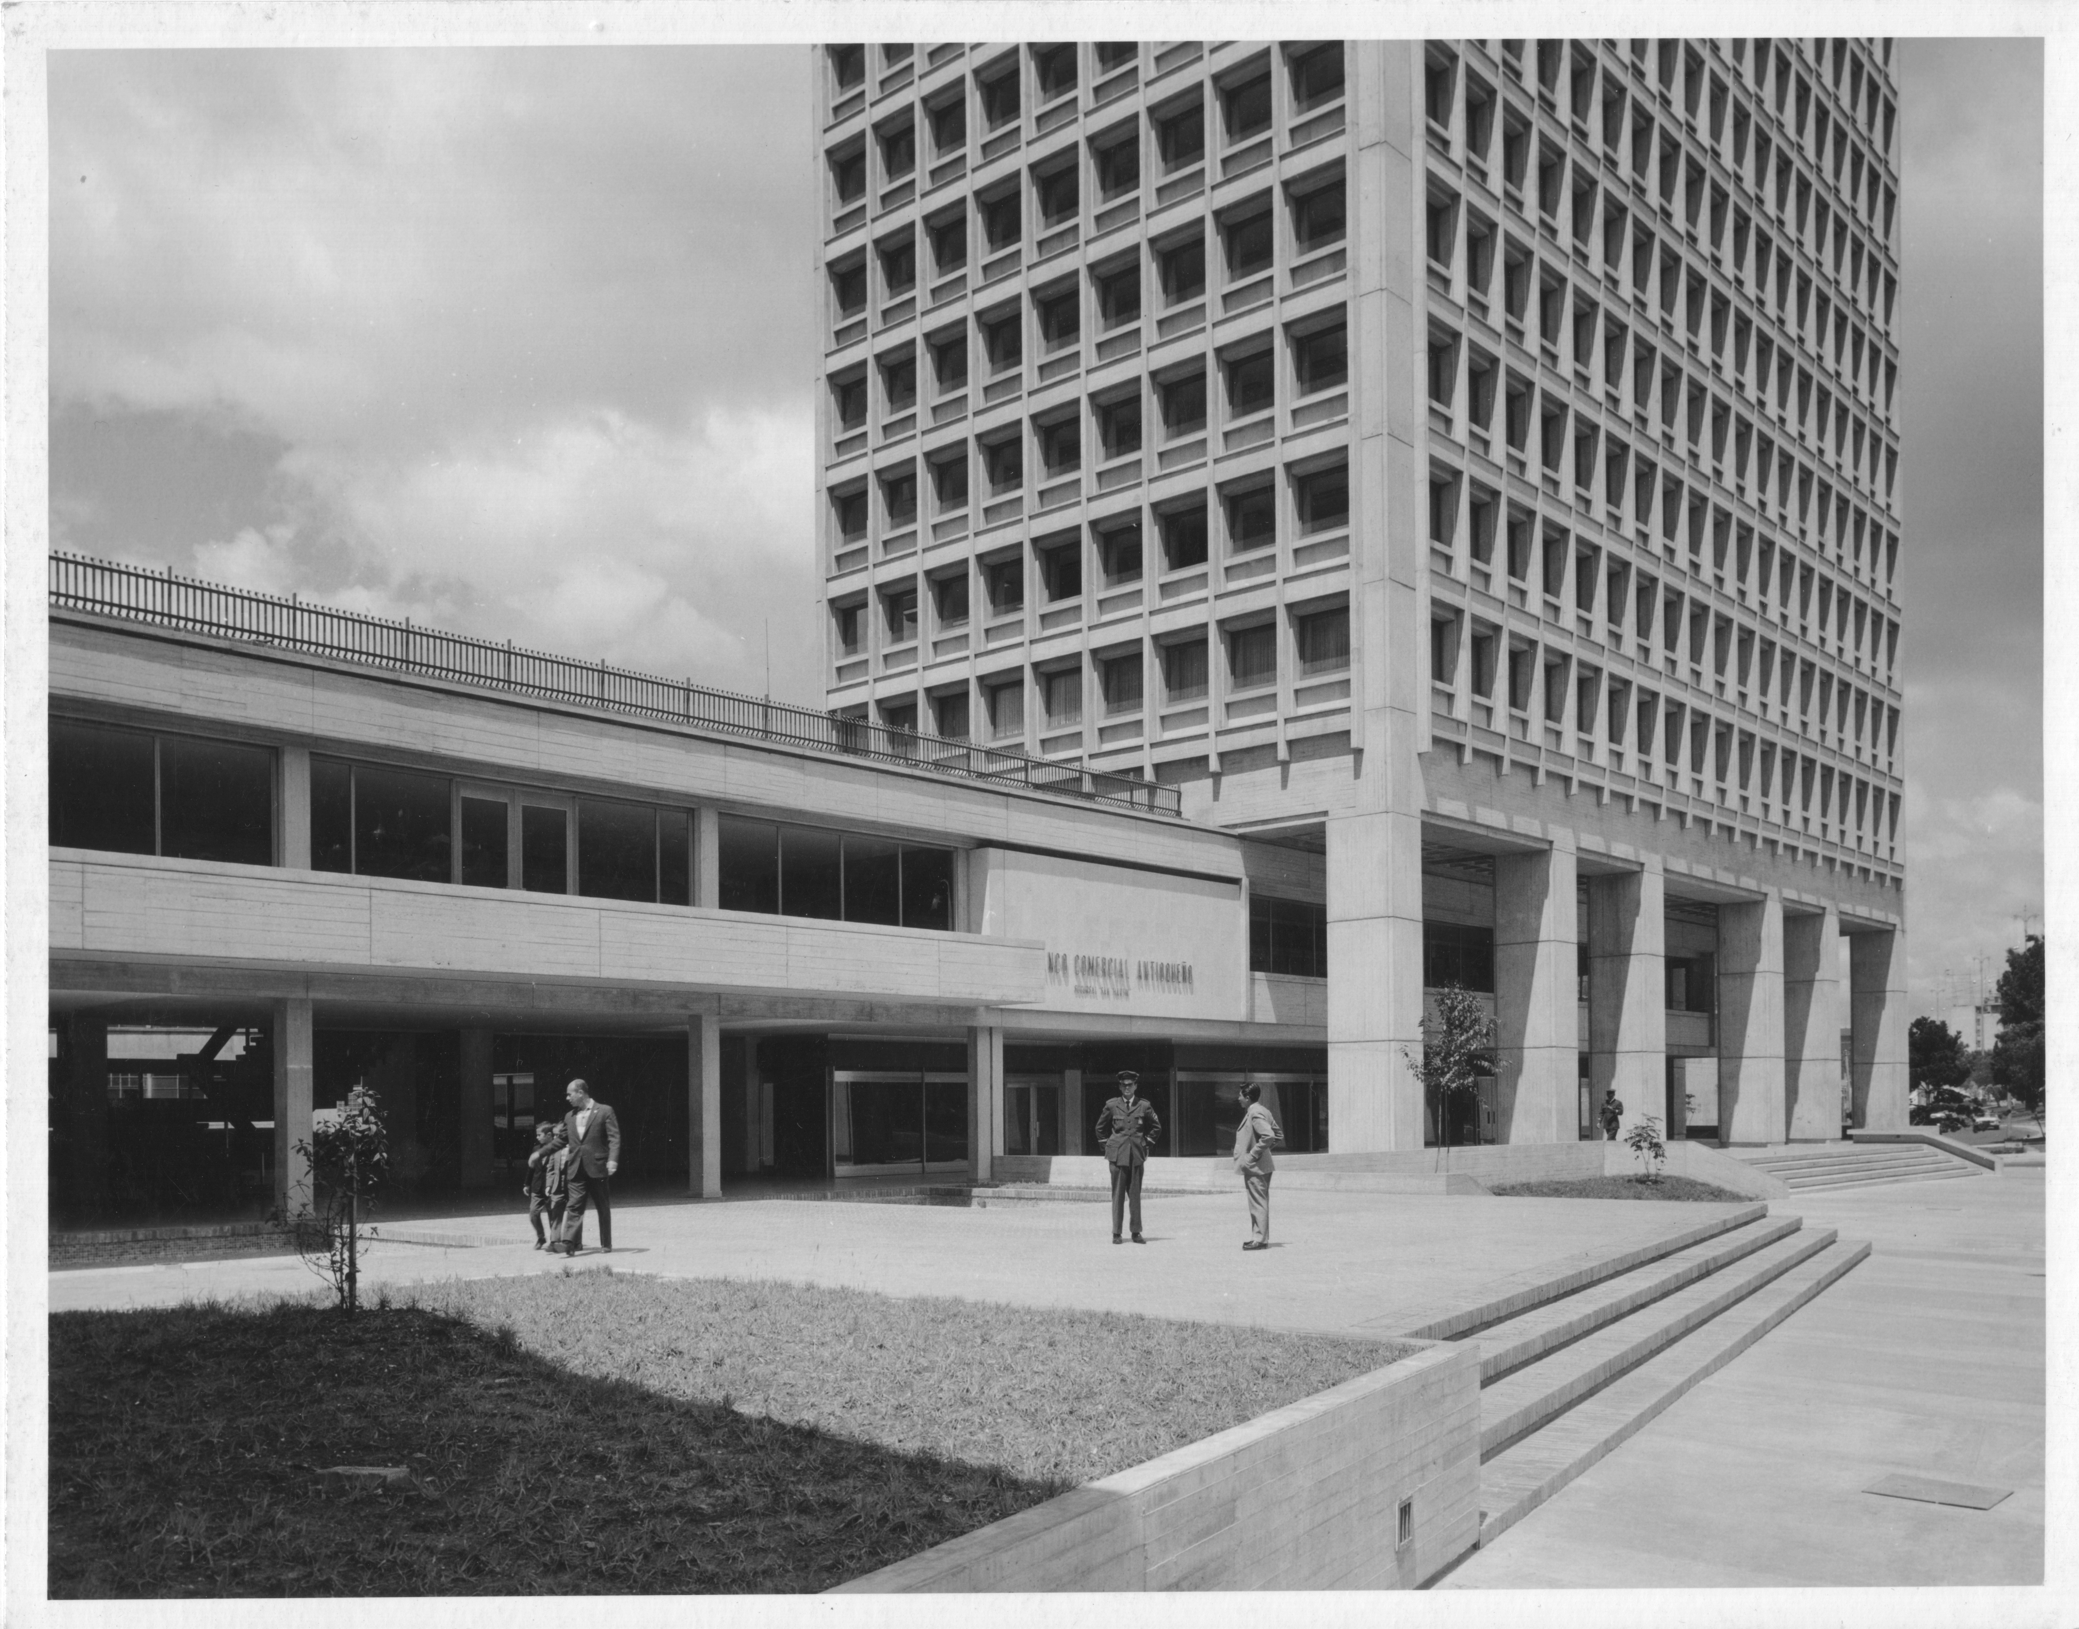

Bavaria complex in Bogotá, with the firm Pizano-Pradilla-Caro (1962-66)

## Copyright material

Name of your entry in the Encyclopedia: Obregón & Valenzuela

Material you want to use: Alvaro López house

Purpose of inclusion: *example*

Link to Material (if online):

Bibliographic details (if appropriate):

Copyright holder: Obregon & Valenzuela archive

Any other useful information: Edgar Bueno

Name of your entry in the Encyclopedia: Obregón & Valenzuela

Material you want to use: Mario Santodomingo house

Purpose of inclusion: *example*

Link to Material (if online):

Bibliographic details (if appropriate): Proa journal, 36, June 1950

Copyright holder: Proa journal

Any other useful information: Lorenzo Fonseca lfonmar@gmail.com

Name of your entry in the Encyclopedia: Obregón & Valenzuela

Material you want to use:  Country club in Ibagué

Purpose of inclusion: *example*

Link to Material (if online):

Bibliographic details (if appropriate): Proa journal, 111, August 1957

Copyright holder: Proa journal

Any other useful information: Lorenzo Fonseca lfonmar@gmail.com

Name of your entry in the Encyclopedia: Obregón & Valenzuela

Material you want to use:  Rafael Obregón house

Purpose of inclusion: *example*

Link to Material (if online):

Bibliographic details (if appropriate):

Copyright holder: Obregón & Valenzuela - Rafael Obregón Herrera

Any other useful information: Rafael Obregón Herrera asroyco_06@yahoo.es

Name of your entry in the Encyclopedia: Obregón & Valenzuela

Material you want to use:  Eduardo Shaio house

Purpose of inclusion: *example*

Link to Material (if online):

Bibliographic details (if appropriate):  Gómez Amorocho, Pedro. (1960) *Moderna Bogotá arquitectónica.* Bogotá: Suramericana

Copyright holder: s.d.

Any other useful information: prensablaa@banrep.gov.co

Name of your entry in the Encyclopedia: Obregón & Valenzuela

Material you want to use:  French and Italian bank

Purpose of inclusion: *example*

Link to Material (if online):

Bibliographic details (if appropriate):

Copyright holder: Archivo Pizano Pradilla Caro Restrepo Limitada

Any other useful information: [www.ppcr.co](http://www.ppcr.co) [info@ppcr.co](mailto:info@ppcr.co)

Name of your entry in the Encyclopedia: Obregón & Valenzuela

Material you want to use:  Bavaria Complex

Purpose of inclusion: *example*

Link to Material (if online):

Bibliographic details (if appropriate):

Copyright holder: Fondo Obregon & Valenzuela- Archivo Bogotá

Any other useful information: [contactoarchivodebogota@alcaldiabogota.gov.co](mailto:contactoarchivodebogota@alcaldiabogota.gov.co)

1. (Martínez, 1950)
2. <http://www.obreval.com/>
3. <http://issuu.com/revistaproyectiva/docs/proyectiva_3>
4. <http://dearq.uniandes.edu.co/fascicles>
5. (Sánchez-Beltrán, 2010)
6. (Mendoza Neira, 1965, p. 292),
7. (Arango & Martínez, 1951, pp. 135-136),
8. (LLanos, Henao, Fontana, & Mayorga, 2012)
9. <http://www.banrepcultural.org/category/autores-dccreator/obreg-n-valenzuela-0>
10. <http://www.estostock.com/SwishSearch?Keywords=obregon>
11. <http://revista.dpa.upc.edu/02-ARCHIVO/DPA%2024/dpa24.html>
12. <http://issuu.com/ceetnuevosmedios/docs/gaceta_min_cultura>
13. [<http://www.agenciadenoticias.unal.edu.co/nc/ndetalle/cat/video/pag/10/article/obregon-y-valenzuela-creadores-de-arquitectura-universal.html>](http://www.a57.org/articulos/resena/Obregon-y-Valenzuela-en-Bogota-1949-1969-Lecciones-sobre-Arquitecturas-Urbanas)